5. My Academy team at Cognizant want to create a dashboard containing the details of ongoing and completed cohorts. A react application is created which displays the detail of the cohorts using react component. You are assigned the task of styling these react components.

Step1:Unzipping the given folder



Step2:Opening the folder in VS Code and creating a CohortDeatils.module.css file in src

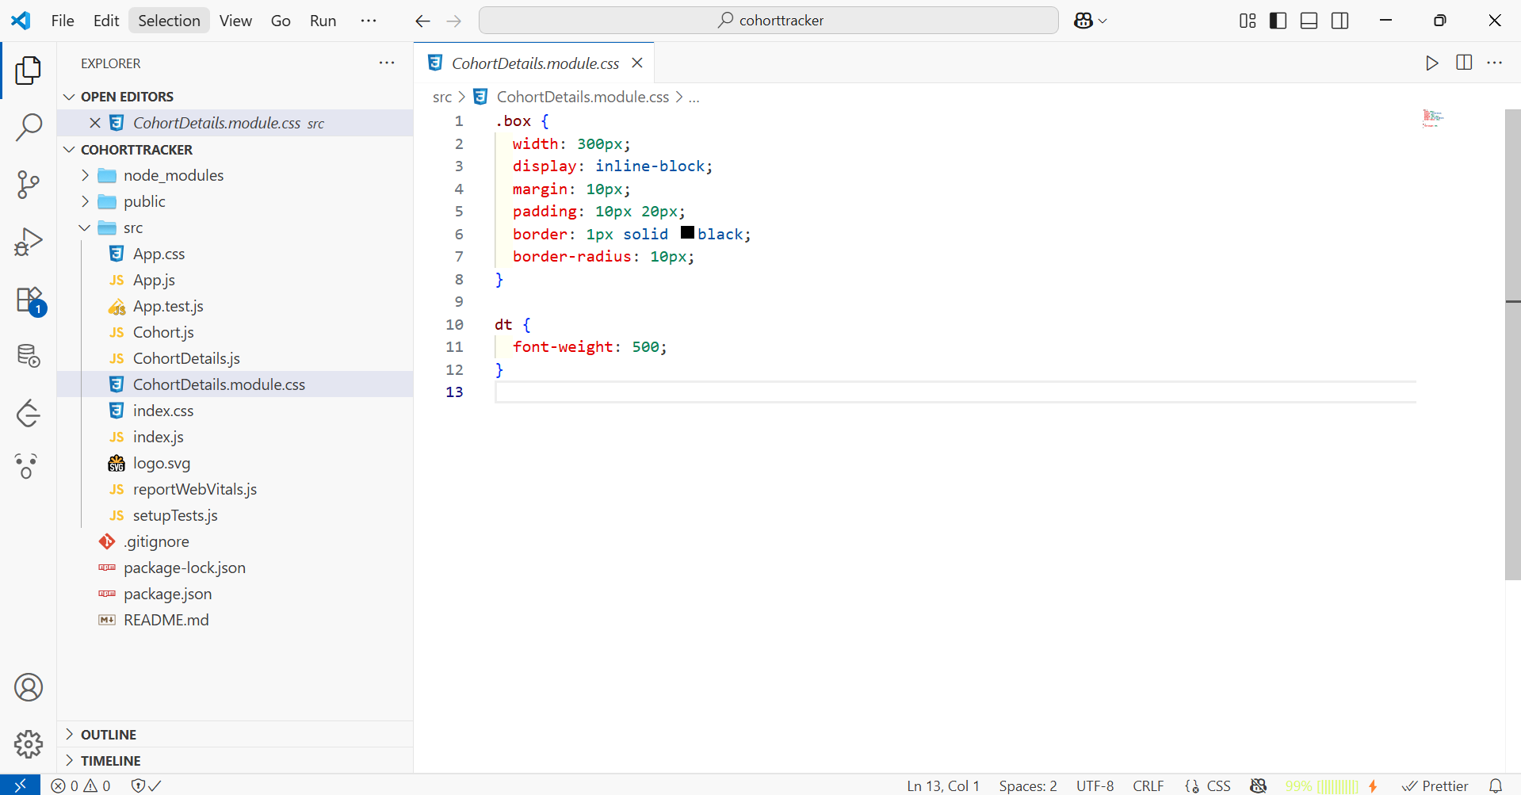

Step3:Updating the CohortDetails.js

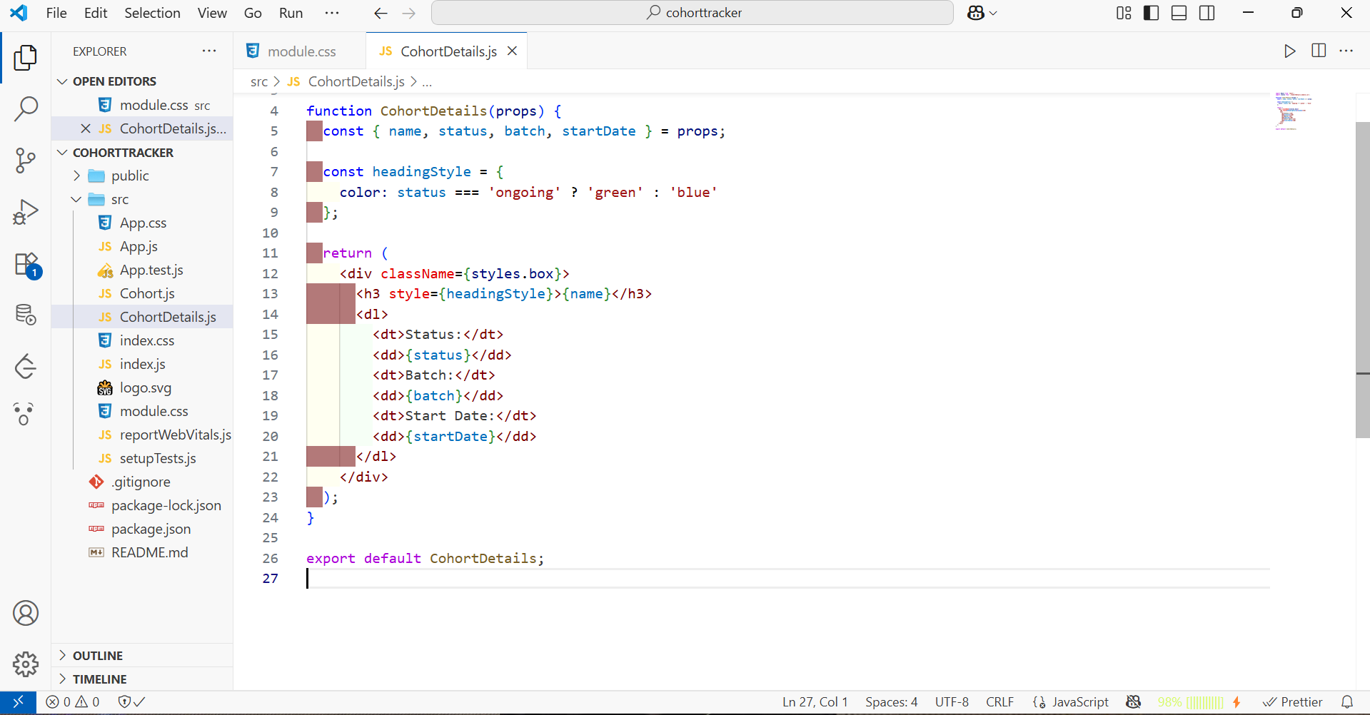

Step4:Running the file and viewing it in the browser

